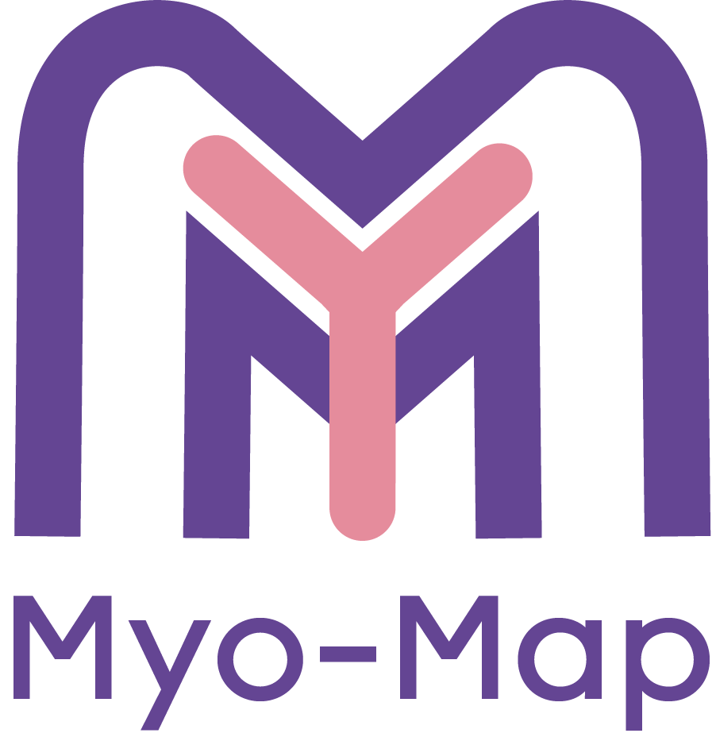
FAQs Myomap
Is it mandatory to have a named consultant before registering this QUIP?
No, it is not mandatory. However, having a consultant involved, especially one with a specialist interest in Minimal Access Surgery/ Advanced Laparoscopy who is are fully aware of and is in support of the project, will help to make this a successful project.
Can I have more than one representative in a unit?
Yes you can have more than one representative and this can be particularly helpful in larger units. Having two or more representatives at each hospital will make the process of data collection smoother. Having 2 RURs at each hospital will make the process of data collection smoother Having 2 RURs at each hospital will make the process of data collection smoother
Does it matter that my unit did not do any laparoscopic myomectomies in the specific period 2017-2019?
No, it does not matter if your unit did not do any laparoscopic myomectomies in that specific period. The data collected on abdominal myomectomies will be useful to:

  - To determine the proportion of abdominal, both laparoscopic and open, myomectomies performed for the management of uterine fibroids in 2017-2019.
  - To ascertain the demographics of patients who underwent myomectomy in 2017-2019.
  - To extrapolate how many open myomectomies could have potentially been performed laparoscopically looking at pre-operative criteria

Why is the data collection period 2017-2019?
This specific time-frame was selected for three reasons:
- To capture real input data for the women, their preferences and meaningful data on patient outcomes to compare with the data from NHS digital

- Due to covid, data collected on laparoscopic myomectomy from 2020 onwards would be looking at the backlog of cases that would have waited two years for their myomectomy. Local data shows more women are proportionally having open myomectomy post pandemic as their fibroids are bigger.

- This will help to inform a prospective study on the surgical management of uterine fibroids

I rotate to another hospital in August which could potentially lead to not being able to meet the requirement for data submission at the end of September– will there be an extended deadline?

We acknowledge that many doctors will be rotating to a new unit in August. For this reason, we anticipate extending the deadline to October to ensure we achieve a high completion rate and the required UK coverage. The main point is ensuring that these doctors know what the project entails and have all the required information: invitation letter, protocol, video and data collection sheet. This would ideally allow them to register the project in their new unit as soon as possible. Alternatively, you could consider enlisting the help of a doctor who is not rotating in August to help complete the data collection in your current unit.

If you have any further questions please drop us an email: projectmyomap@gmail.com

Good luck and thank you for helping to hopefully make this project a huge success.

Kind regards,

Team Myomap

